AWS :

# **How to connect an EC2 instance if you lost your keypair (.pem) file ?**

Step 1:login to aws console.

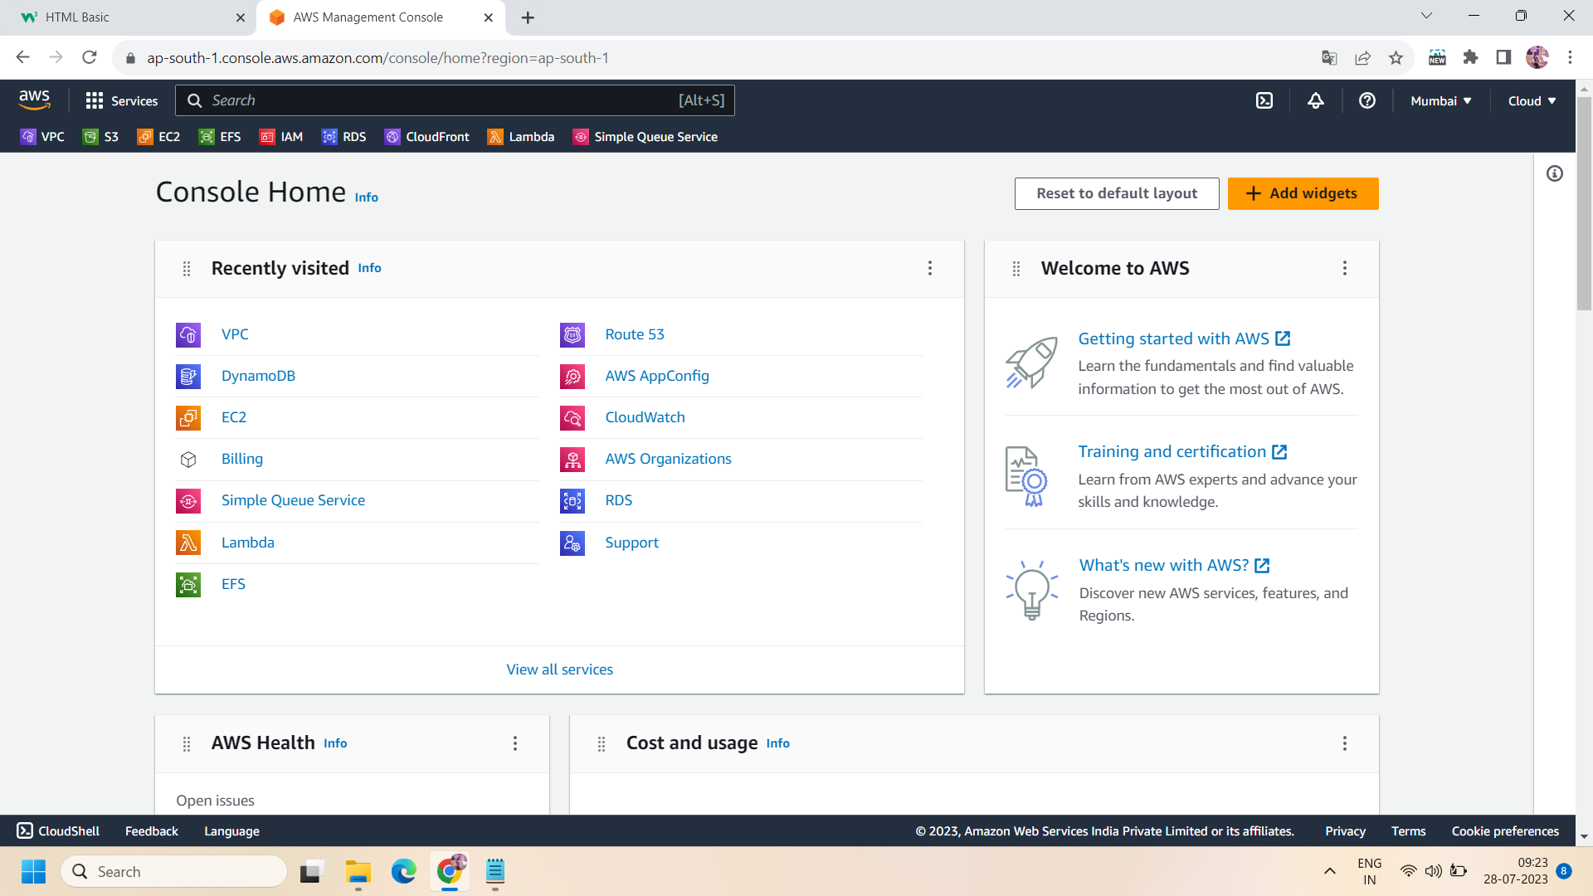

Step 2: navigate to ec2 console and launch an instance .eg., we launch an instance “instance-01” having linux AMI,default VPC and subnet in region ap-south-1a ,enabled auto assigned public ip,key pair with name “loss-keypair” and security group “launch wizard-3” allowed SSH and HTTP inbound rules.

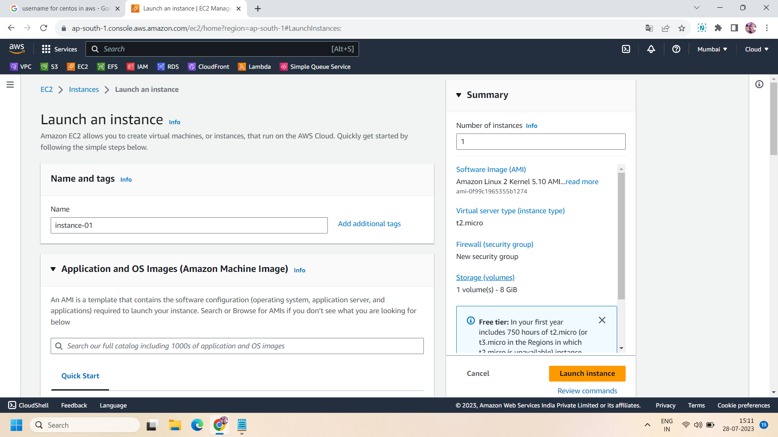

Step 3: take ssh of your instance using any ssh software ,we use putty and puttygen to convert the .pem file into a private key file and login to linux server.

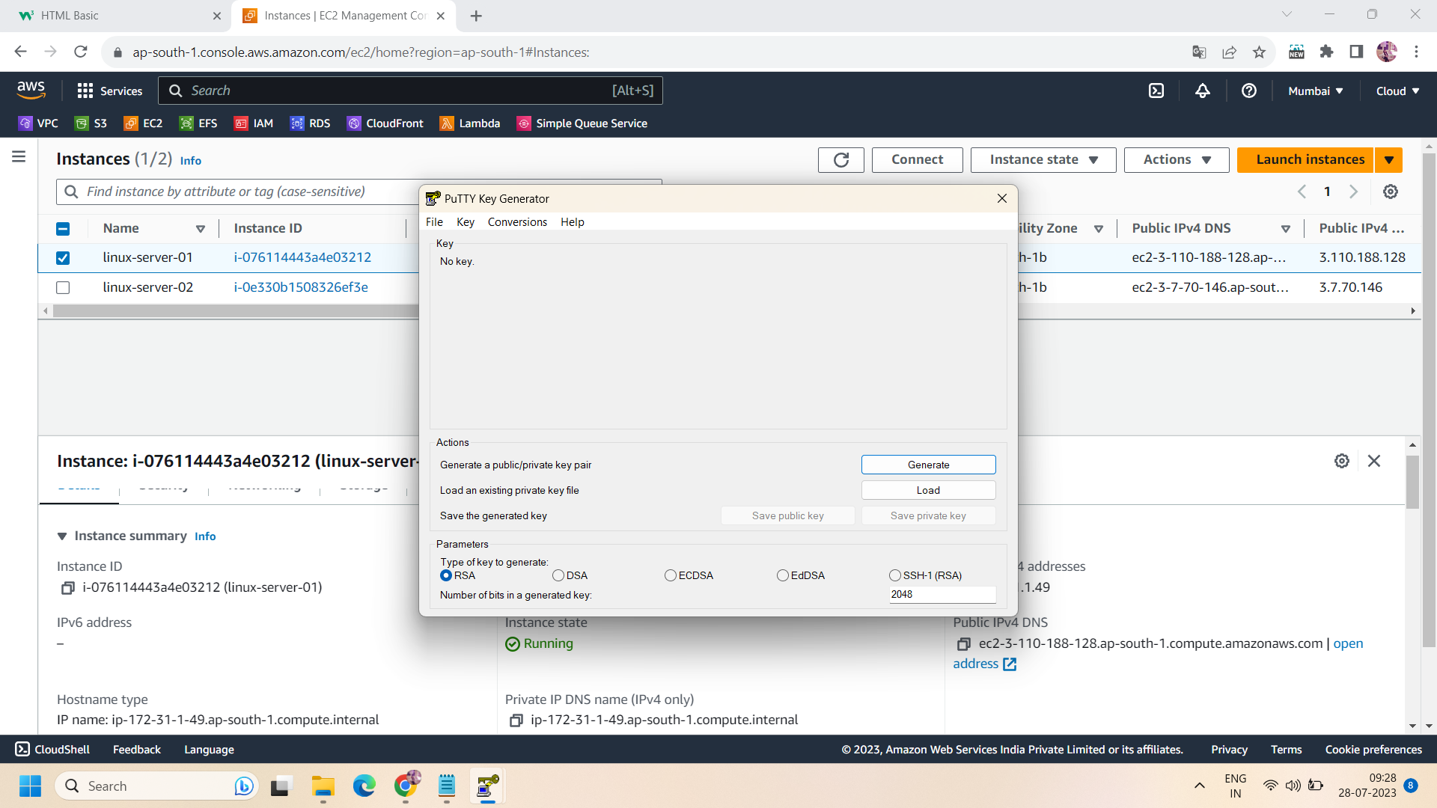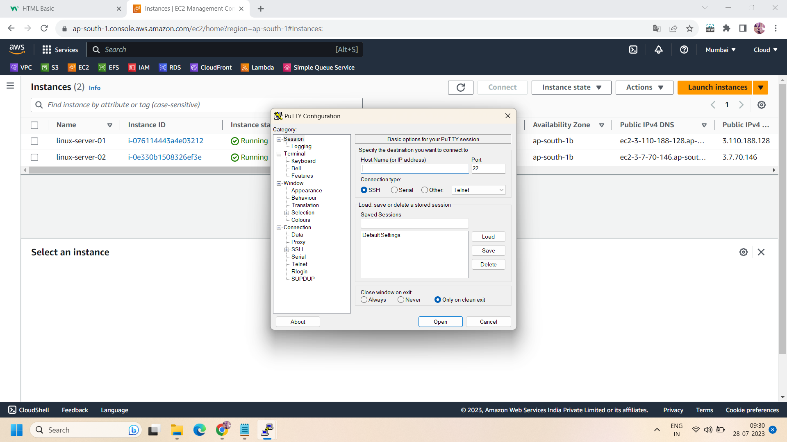

Step 4: On successfully login to your linux server run the following commands :

* ,first change to root user using command :

**sudo su -l**

* Now put some data to your linux server using following commands :

**mkdir /tmp/testfiles**

**cd /tmp/testfiles**

**touch testfiles{1..10}.txt**

**ls**

* Now after putting the above data ,logout from your linux server:

**cd**

**logout**

**logout**

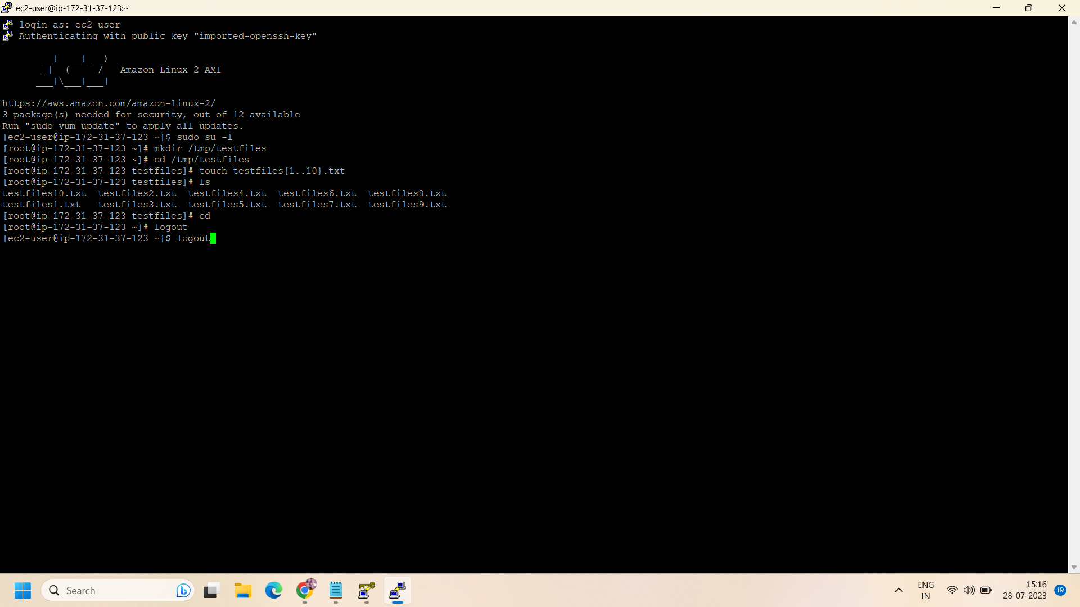

Step 5: Now delete the key pair (.pem file) of your instance. Or somehow you lost it then by following the below steps you can recover the data with the lost key.

Step 6: Now ,create a new instance (e.g., recovered instance with name “new-instance”) within the same region and VPC that of instance-01 (old instance) ,same security group and rest all the specification would be the same .

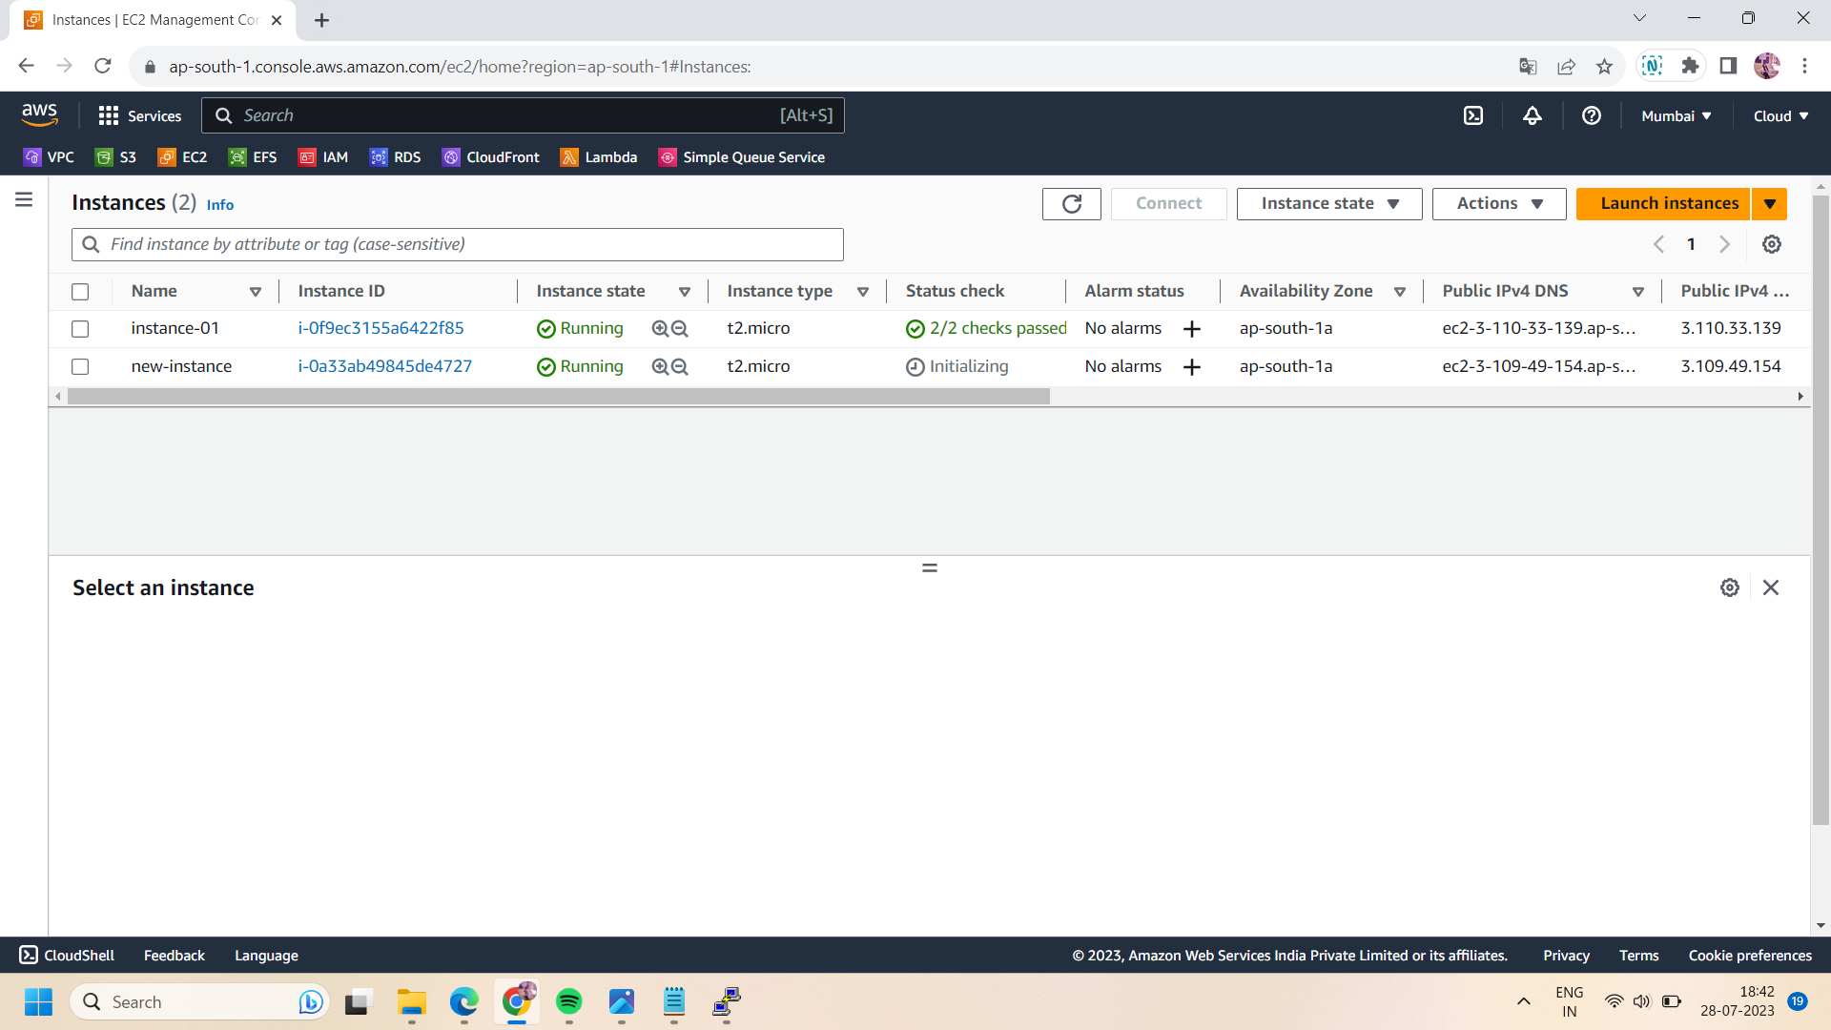

Step 7:After launching the new instance ,take ssh of that and login to the linux server of the new instance.

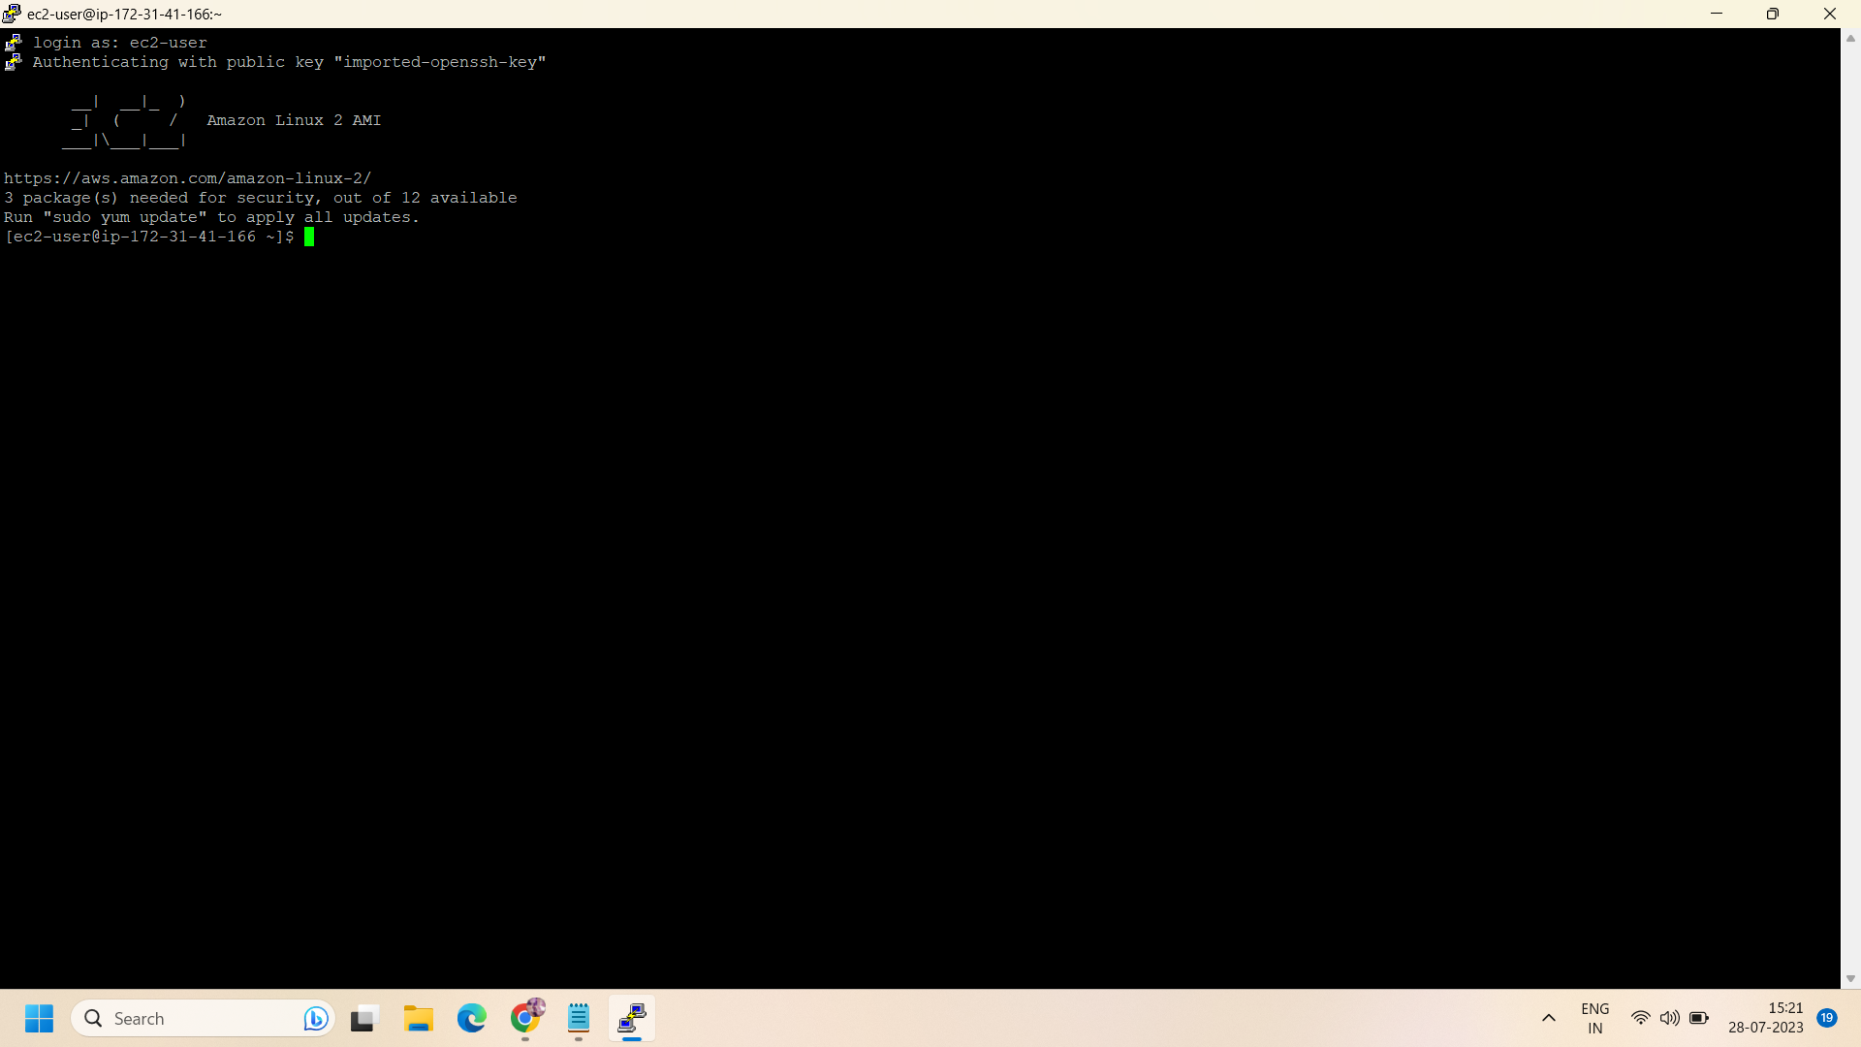

Step 8: Now come to aws console and stop the old instance(instance-01) and go to volumes and detach the attached volume from the old instance.

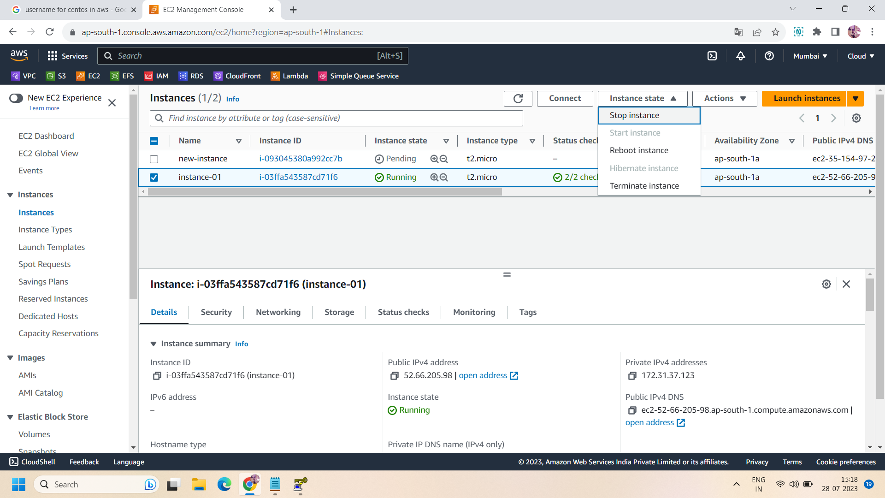

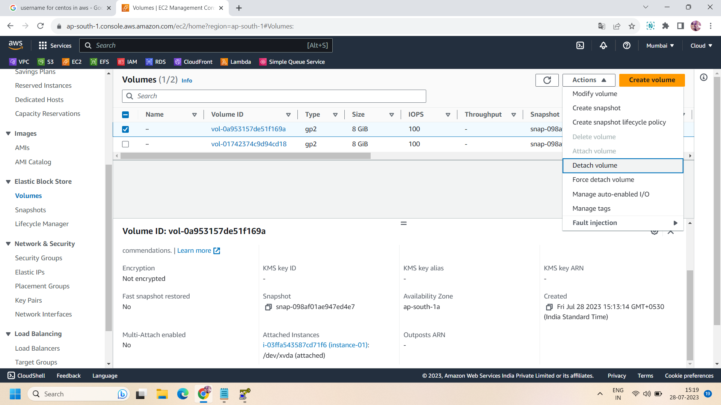

Step 9: Now ,stop the new instance and go to volumes and attach the same volume with the new instance that was detached from the old instance.

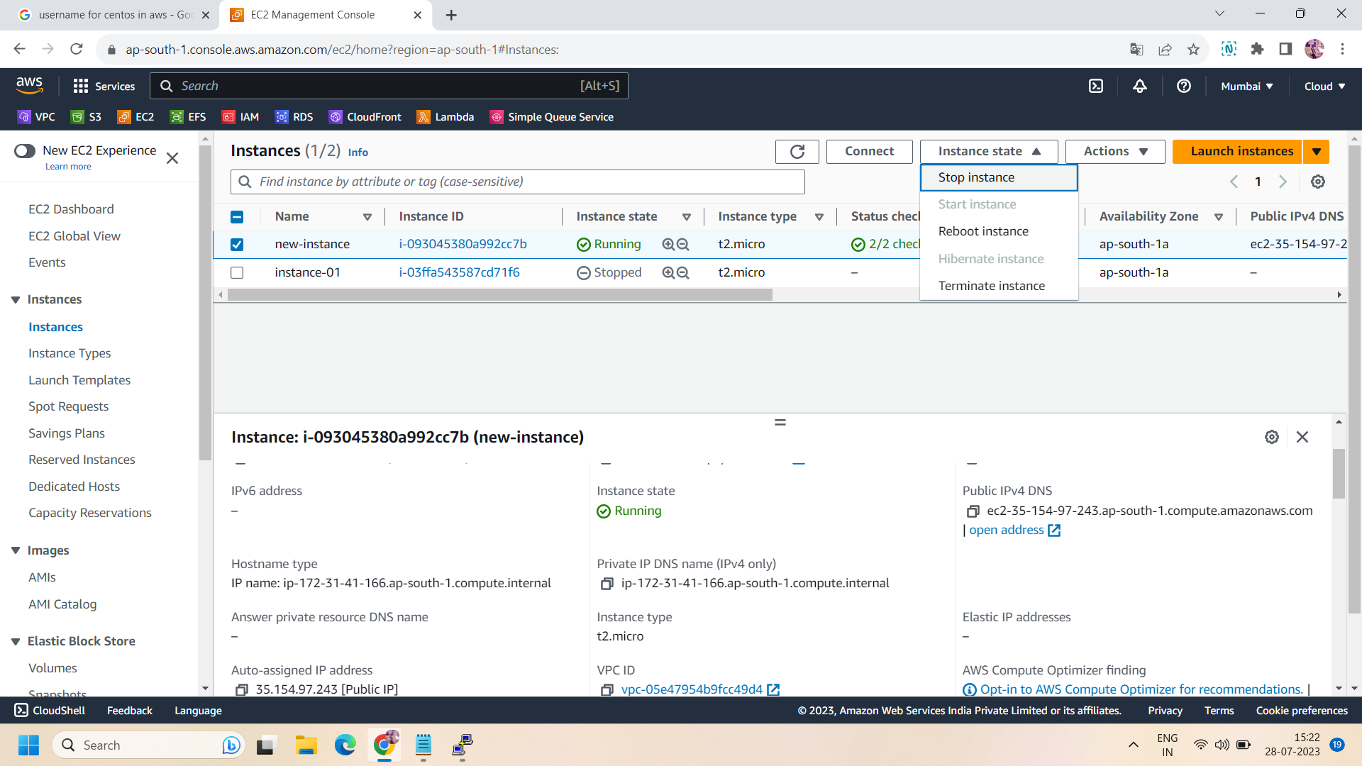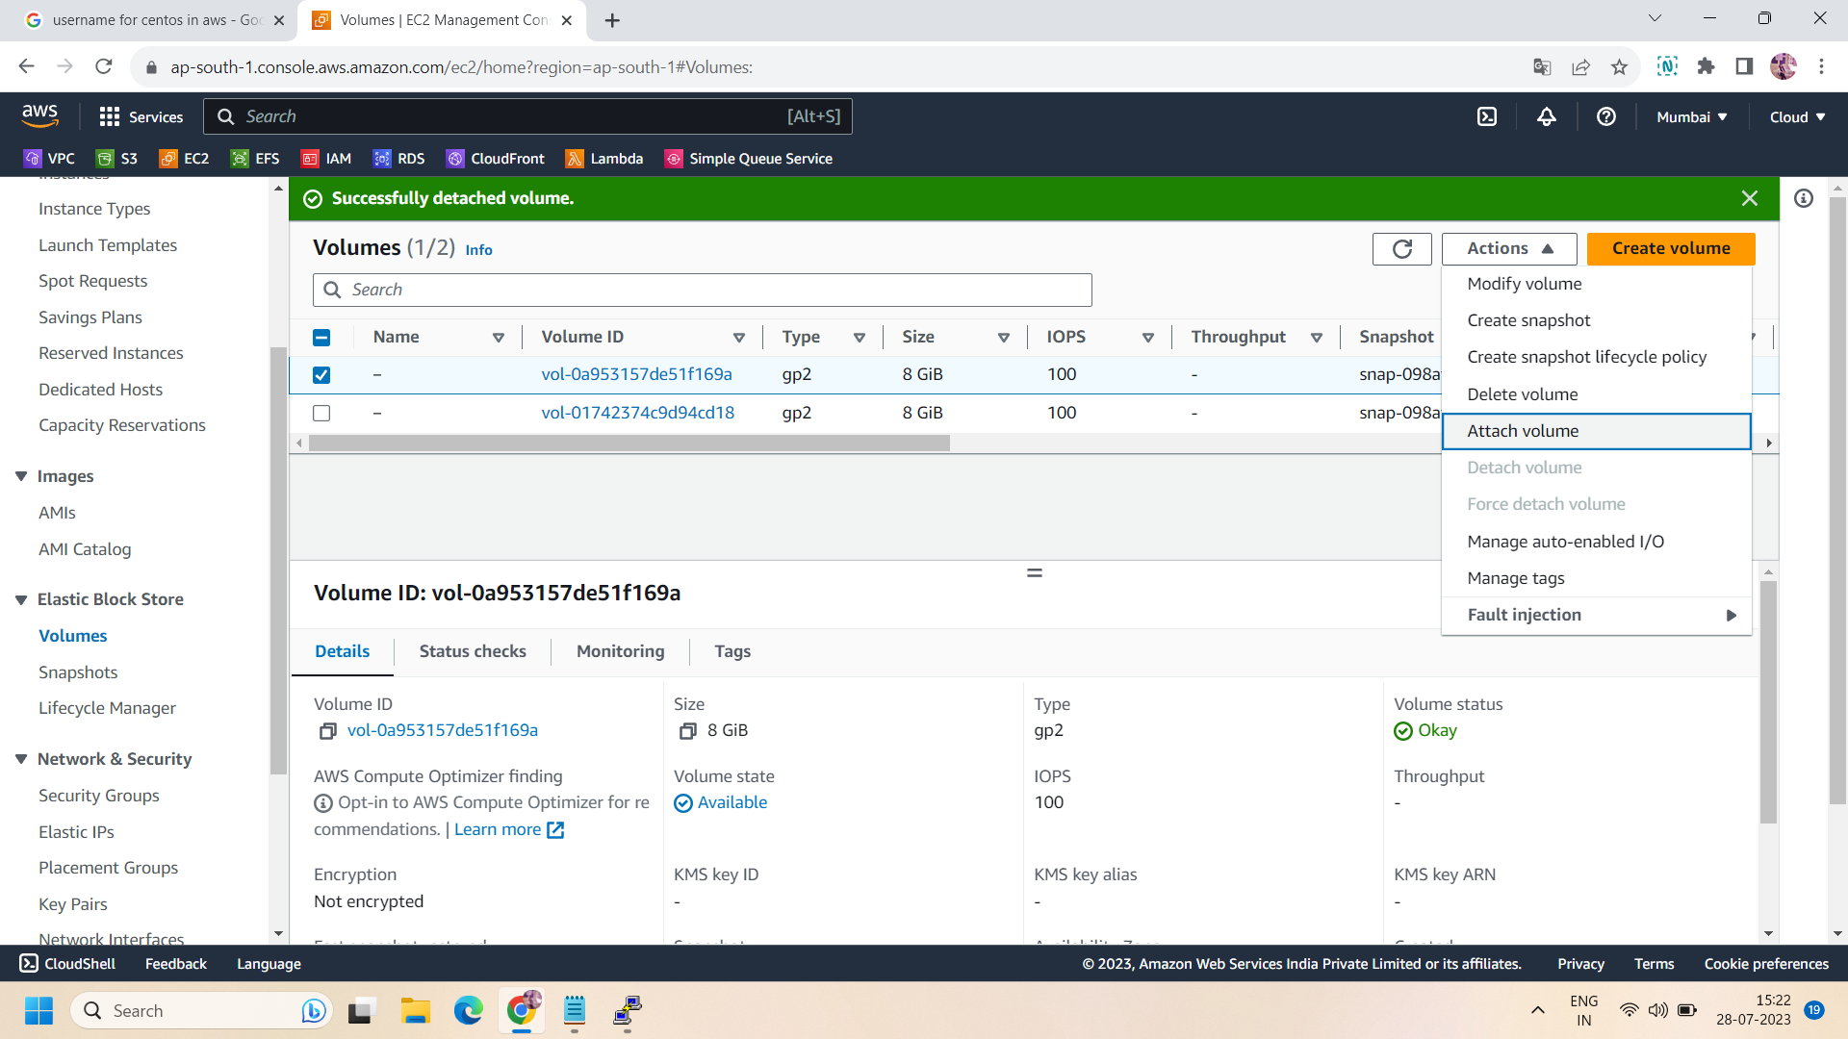

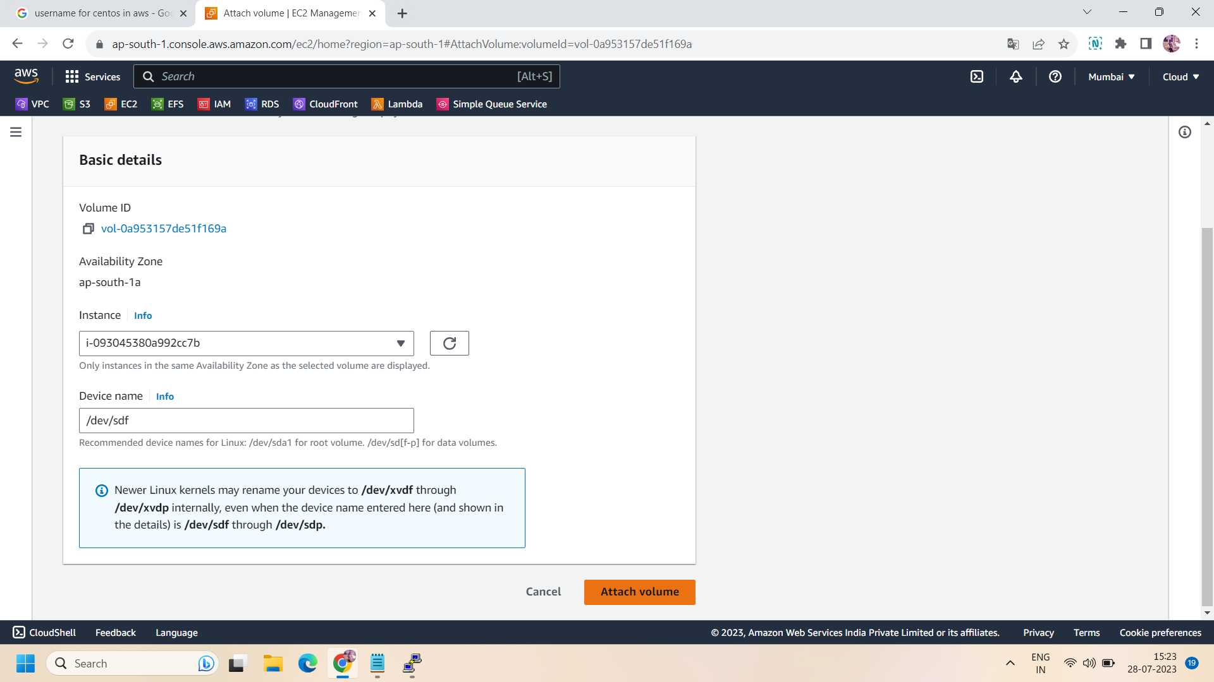

Step 10: after attach the volume with new instance,now go to linux server of new instance and run the following commands :

sudo su -l

lsblk

lsblk -fp

ls /mnt

lsblk

mount -o rw,nouuid /dev/xvdf1 /mnt

ls /mnt

cat /home/centos/.ssh/authorized_keys >> /mnt/home/centos/.ssh/authorized_keys

umount /mnt

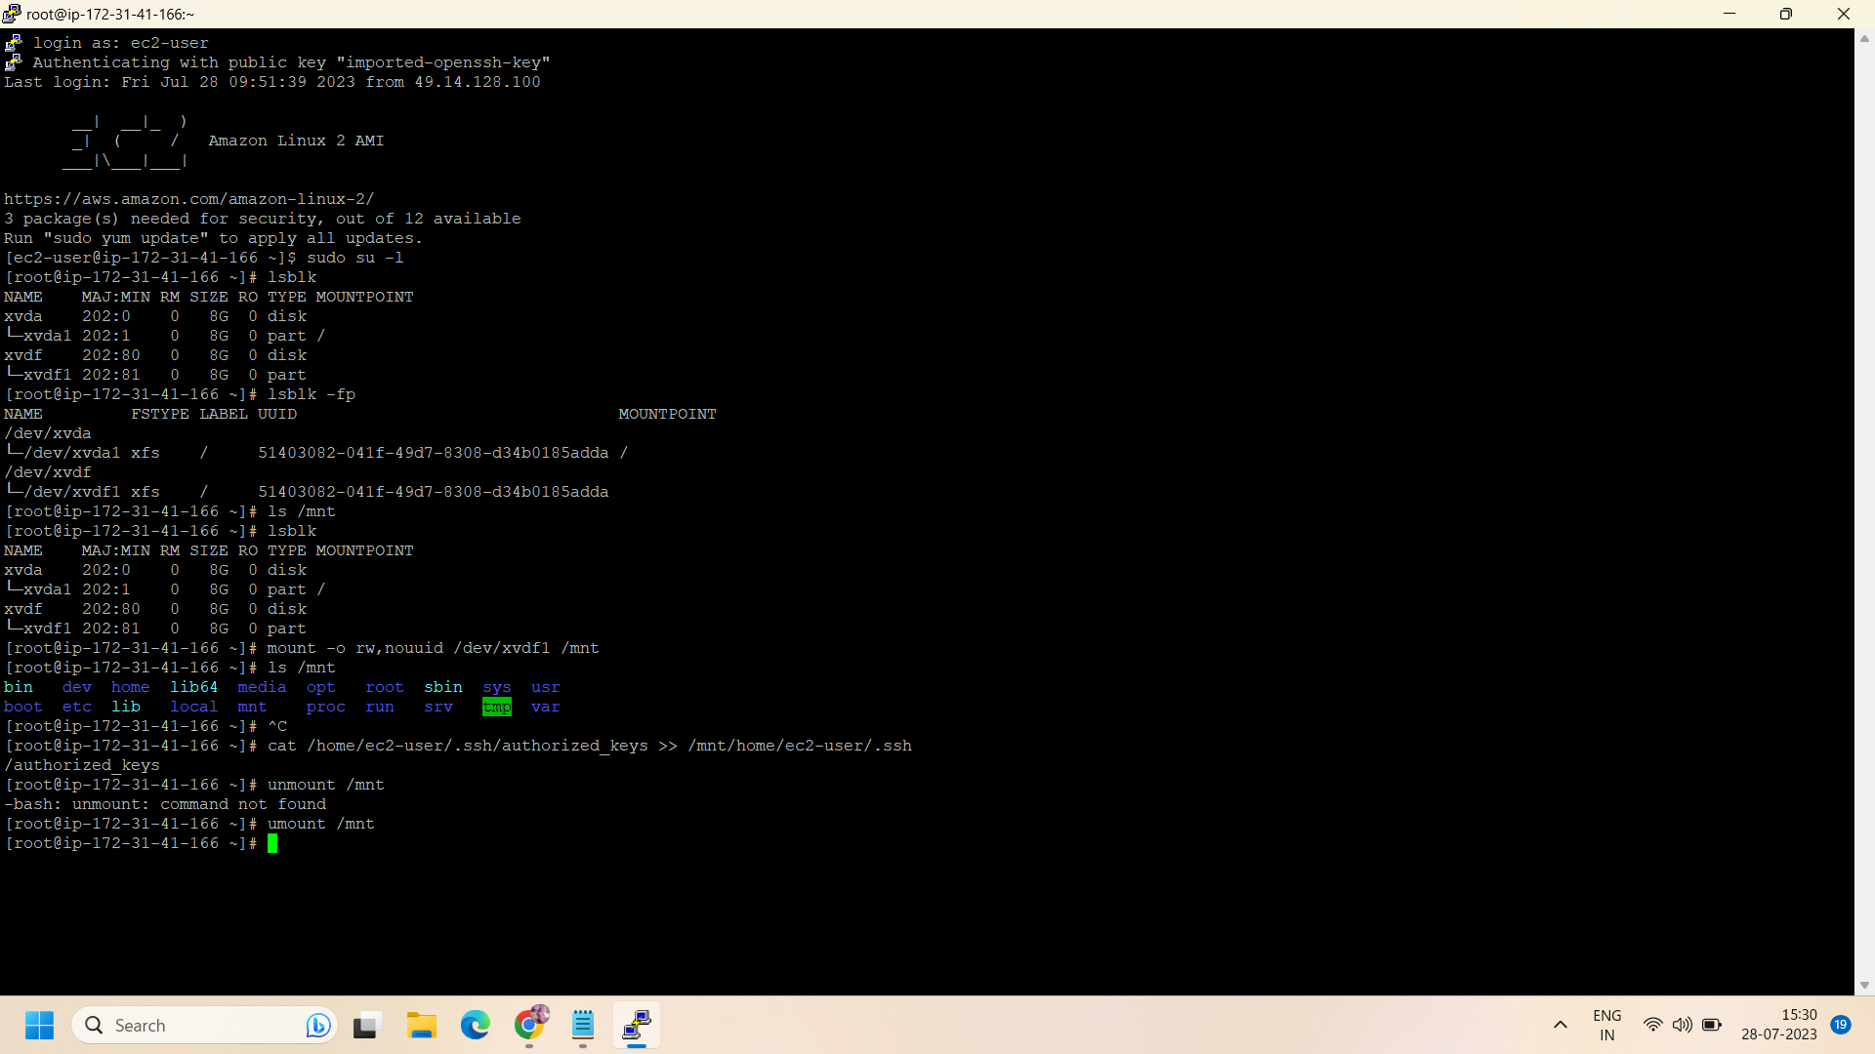

Step 11: After running all the above commands ,go to aws console and stop the new instance and detach the attached volume from the new instance and again attach to the old instance.

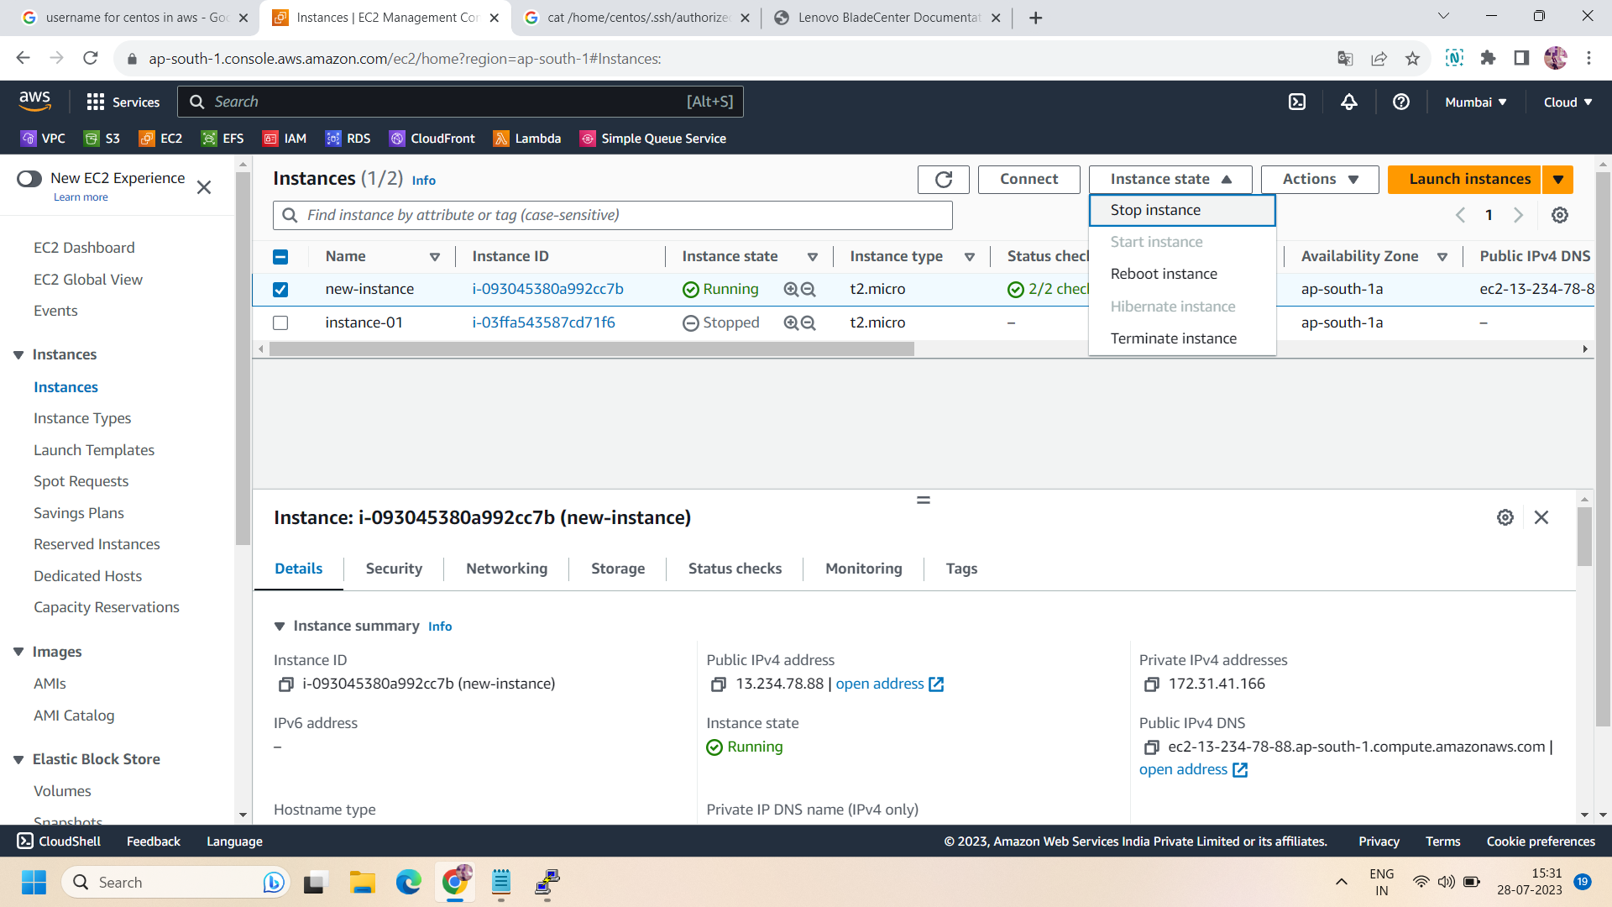

* When you will attach the volume again with the old instance,make sure you change the device name “/dev/xvda” to properly recover the data.

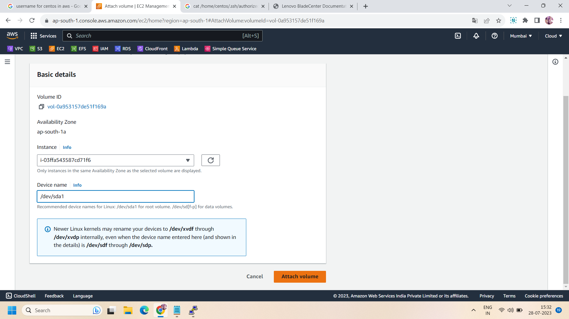

Step 12 : now, take ssh of your old instance using the key pair of new instance.after login to old instance using new key ,run the following commands to check your data whether recovered or not.

sudo su -l

lsblk

ls /tmp/

ls /tmp/testfiles/

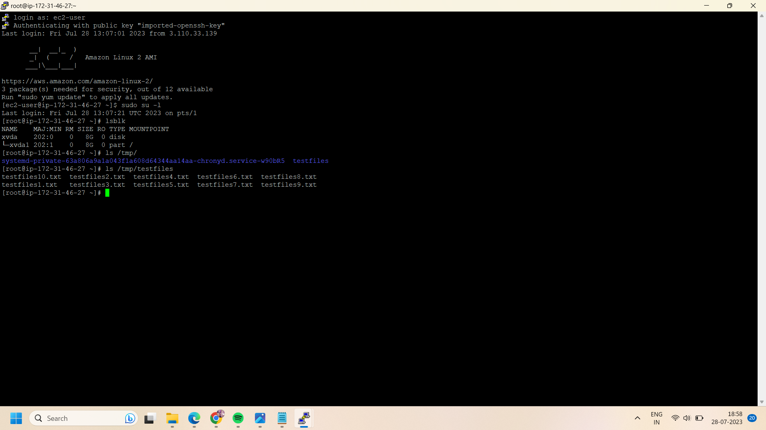

Step 13: Hence , you get your data .That is how you can recover your data of your lost key pair.

Successfully done!!